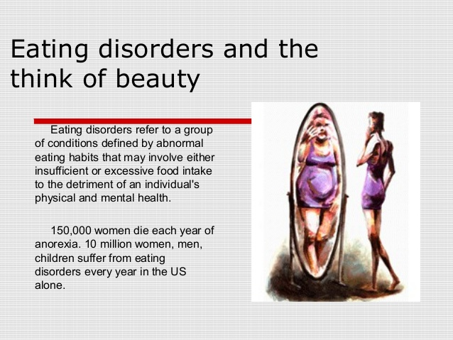
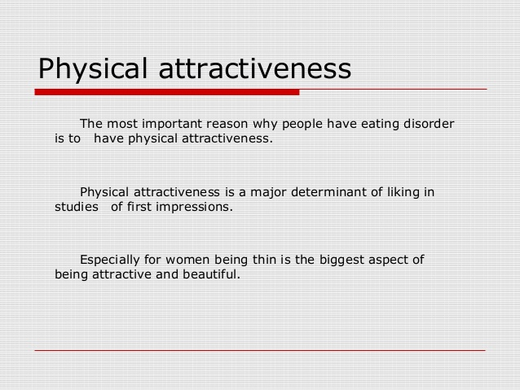
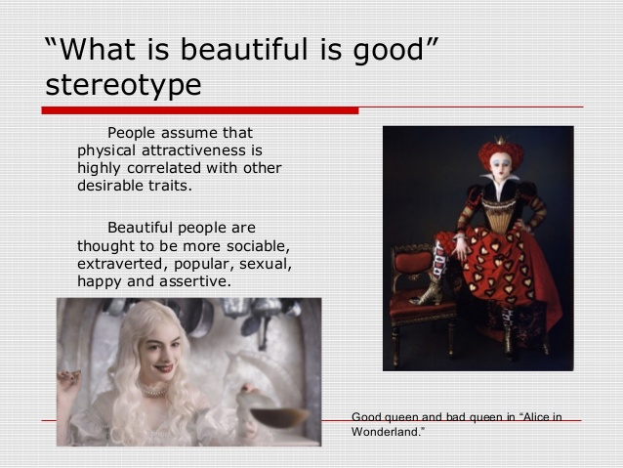
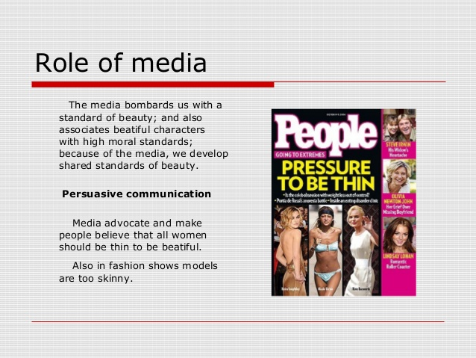
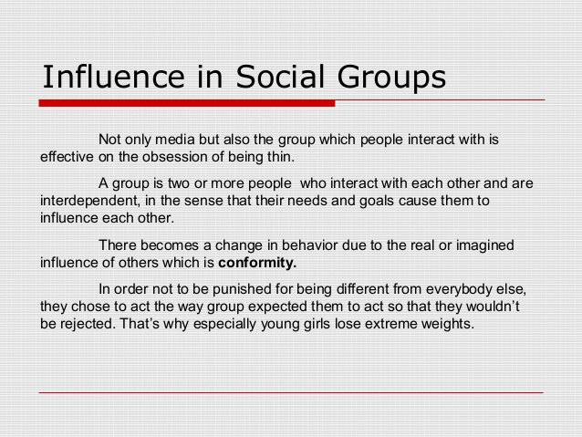
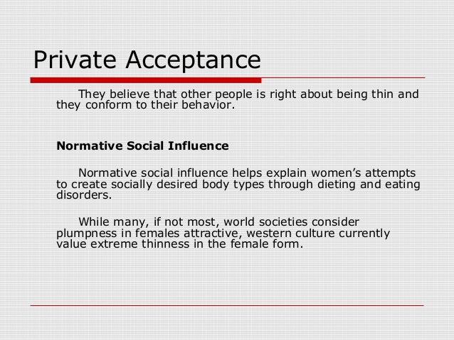
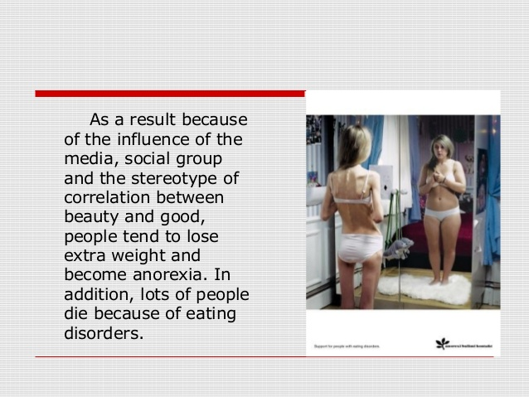

Body Image in the Media
It’s important to understand the impact of body image in the media. Media and body image is important because we are absolutely bombarded with media images these days and those images have a huge effect on our mental health and the way we see ourselves.
The Bureau of Labor Statistics reports that the typical American spends about half of his free time in front of the TV. Television is not the only form of media that influences our body image, of course. We watch movies, see pictures online, read magazines and other periodicals, watch performances by rock stars, see ads for clothing (featuring ridiculously skinny models) and so on. In all these forms of media, we see images of very skinny women.
Body Image in the Media
The average female fashion model weighs about 120 pounds. Meanwhile, the National Center for Health Statistics tells us that the average American woman weighs about 169 pounds. Obviously, there is a huge disparity there. Most people probably don’t realize that the average woman weighs 169 pounds, though, because they assume what they see on TV or in the movies is typical. The unrealistic body image in the media distorts reality and leads people to believe they are abnormally heavy when they really aren’t.
Issues of the media and body image are important because of the rise in eating disorders and other disorders related to body image. Certainly not all people with eating disorders have been negatively affected by the media and the media is probably not the sole cause of eating disorders in anybody. However, it is often a contributing factor.
Problems Caused by Body Image in the Media
As mentioned above, the unrealistic images we see in the media can contribute to the development of eating disorders like anorexia and bulimia. People with anorexia restrict the number of calories they eat. Many do this because they believe they are overweight, even when in reality they may be dangerously thin. People may become anorexic for other reasons; for instance, some control their food intake as a way of maintaining some control over lives that seem unmanageable. A distorted body image is a common factor in anorexic people, however.
Anorexia and bulimia are very serious disorders. They lead to all sorts of health problems, including heart disease and kidney disease. People can die from these disorders if they don’t get proper treatment.
Mass media provides a significantly influential context for people to learn about body ideals and the value placed on being attractive. Whenever you use media, think about who is paying for your attention. Consider how the message might affect someone’s body confidence and if it is a message you want to support.
- Numerous correlational and experimental studies have linked exposure to the thin ideal in mass media to body dissatisfaction, internalization of the thin ideal, and disordered eating among women.
- Of American elementary school girls who read magazines, 69% say that the pictures influence their concept of the ideal body shape. 47% say the pictures make them want to lose weight. (Martin, 2010).
- Pressure from mass media to be muscular also appears to be related to body dissatisfaction among men. This effect may be smaller than among women but it is still significant.
- Conversely, Black-oriented television shows may serve a protective function; Hispanic and Black girls and women who watch more Black-oriented television have higher body satisfaction.
5 TIPS FOR MEDIA SELF CARE
- Choose and use media mindfully. Be selective about your media use and choose media that supports your values and builds self-esteem and body confidence.
- Limit screen time and social networking. Researchers studying body concern issues have found that the more time we spend in the media world, the more we are exposed to body perfect images, and the more vulnerable we are to compare our appearance to unrealistic body standards. Protect your self-image by monitoring the quantity and quality of your mainstream and social media time.
- Test the message for body positivity. Use media literacy strategies to think critically about messages you consume and content you create on social media. Test for body positivity by asking key questions: Are the body depictions realistic or digitally altered? What does the message really mean? Why are they sending it? How might it affect someone’s body acceptance? Who created and profits from the message? Before you text, tweet, post comments, and share photos and videos, ask yourself why you are sending the message, who you want to reach, and analyze its body positivity.
- Talk back to media about body image. Tell people who profit from media and establish policies what you like and don’t like about their body representations, why you feel this way, and what you plan to do about it — take a stand and refuse to read, view or listen to media or buy advertised products until they make changes.
- Advocate for positive body talk. Use your social media capital to inspire others to use their voices to compliment authentic and diverse body messages, criticize unrealistic body ideals, and report body shaming. Shout out to media outlets, retailers, advertisers, and celebrity product endorsers who celebrate natural looks, healthy body size, and diverse body shapes, and call out ones that continue to promote unhealthy and artificial body norms. You can make a difference!
- The National Eating Disorders Association reports that one in every 3.8 televisions commercials conveys an “attractiveness message,” telling viewers what is considered attractive. These messages convey the idea that extreme thinness is much more attractive and desirable than a normal, healthy weight. The typical American teen sees more than 5,260 of these “attractiveness messages” every year. You can see why there would be a connection between eating disorders and body image.
- One study found that the more often young men read fitness magazines, the more dissatisfied they become with their bodies. Another study of a popular magazine for teen girls found that 74 percent of all articles about fitness stated becoming more attractive was a good reason to exercise; articles did not recommend exercise as a way to become healthier, just a way to become prettier. Yet another study found that most adolescent girls get the majority of their information about health from the media – which includes all those “attractiveness messages.”

